**Disassociate Records from 1:N SubGrid**

**Requirement :** Need to remove record/row from the SubGrid instead of deleting it from CRM.

**Tools Used :** CRMCodeEditor, RibbonWorkbench, CRMRestbuilder.

**Steps :-**

1. Used CRMRestBuilder’s Disassociate function to remove the lookup value from the selected record in the grid.
2. The entire code looks like below :-

|  |
| --- |
| function getGridRecordID()  {  debugger;  var currentRecordID = Xrm.Page.data.entity.getId();  var CRID = sliceGuid(currentRecordID);  var selectedRows = Xrm.Page.getControl("EntityB").getGrid().getSelectedRows();  var entityGuid;    selectedRows.forEach(function(selectedRow, i)  {  entityGuid = selectedRow.getData().getEntity().getId();  var EGID = sliceGuid(entityGuid);    var req = new XMLHttpRequest();  req.open("DELETE", Xrm.Page.context.getClientUrl() + "/api/data/v8.2/new_entityas("+CRID+")/new_new_entitya_new_entityb("+EGID+")/$ref", false);  req.setRequestHeader("Accept", "application/json");  req.setRequestHeader("Content-Type", "application/json; charset=utf-8");  req.setRequestHeader("OData-MaxVersion", "4.0");  req.setRequestHeader("OData-Version", "4.0");  req.onreadystatechange = function() {  if (this.readyState === 4) {  req.onreadystatechange = null;  if (this.status === 204 || this.status === 1223) {  //Success - No Return Data - Do Something  } else {  Xrm.Utility.alertDialog(this.statusText);  }  }  };  req.send();  });  var subgrid = Xrm.Page.ui.controls.get("EntityB");  subgrid.refresh();  }  function sliceGuid(fullGUID)  {  var slicedID = fullGUID.substr(1).slice(0, -1);  return slicedID;  } |

1. Add a button the Parent entity of 1:N relationship :-

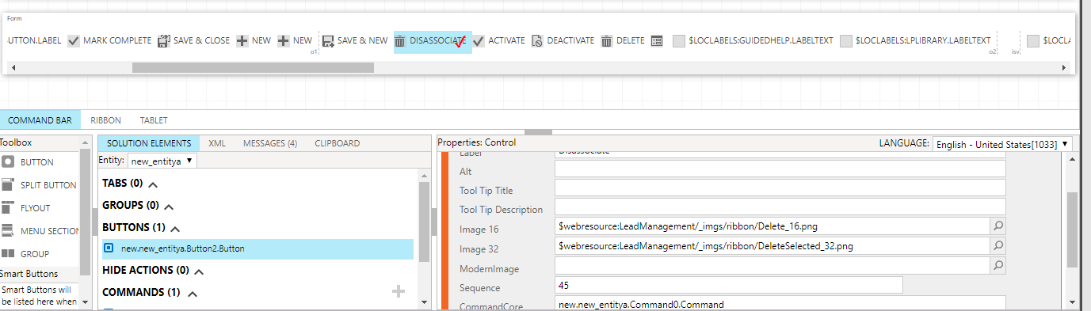

1. Attach a command to the button with JavaScript as action and point the above created JavaScript library :-

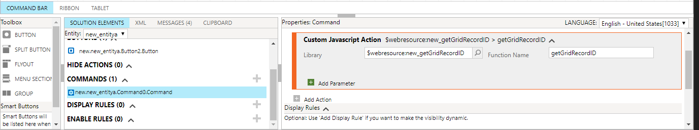

1. Publish the solution.

Output :-

1. Select any record from the SubGrid and click on the disassociate button on the navigation pane :-

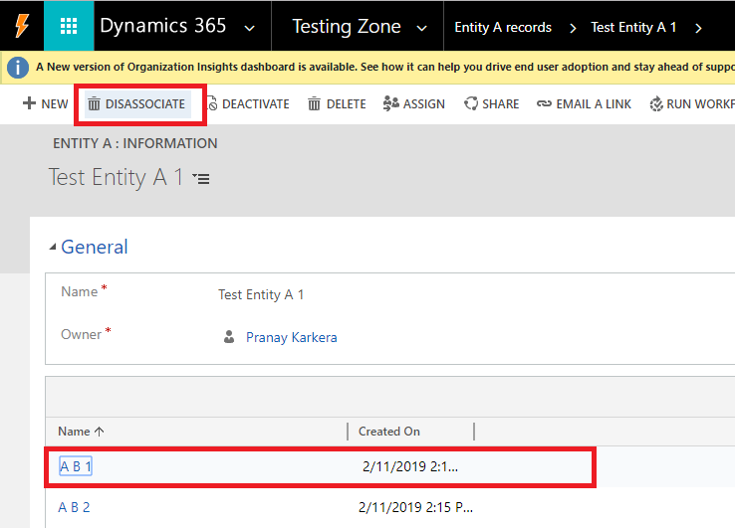

1. The SubGrid will refresh to add the latest changes :-

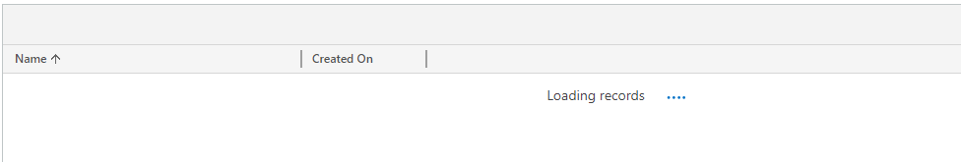

1. Then you will find that the record is no longer available in the grid :-

